Aldabra Tropicbird monitoring

Fernando Cagua

2 June 2016

# Survey effort

Surveys have been consistently performed between effort has been consistent since February 2009, when monitoring began.

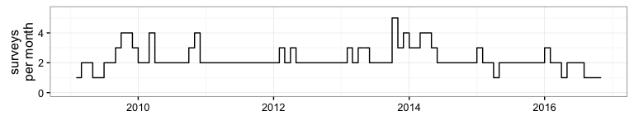

***Figure 1:*** *Number of monitoring surveys performed each month.*

# Breeding seasonality

We investigated the breeding periodicity of *Phaethon rubricauda* and *Phaethon lepturus* by calculating the wavelet power spectrum of the nests established by each species. We constructed a monthly time series of the number of new nests observed per month, and corrected by the number of surveys in each month. In the wavelet method, dominant periods are those that correspond to frequencies with the highest power. P-values to test the null hypothesis that a period is irrelevant at certain time were calculated using 100 randomisations of the nest data series.

In addition, we constructed generalised additive mixed effects model (GAMM) of the number of new nests established by each species on a monthly basis. In these models, we included month as a smooth term to evaluate the variation across the year, while the number of surveys per month was included as a linear predictor to account for differences in effort. To account for potential variation in breeding across years we included it as a random effect. In addition, we expect potential increases in nest establishment to be consistent by an increase on nests that were observed to be occupied by an egg or small chicks not yet feathered. Therefore, we also constructed a series of GAMMs with the same predictors that our original models for these two additional variables.

Both the wavelet and the GLMM indicate a statistically significant seasonality on the establishment of new nests by *P. rubricauda* (p value of the smooth term $<0.001$), but less so for *P. lepturus* ($p=0.83$). These results were strongly supported when examining the seasonality of nests occupied by downy chicks or eggs ( $p<0.001$ in both cases for *P. rubricauda*, and $p=0.1$ and $p=0.54$ respectively for *P. lepturus*).

The wavelet power analysis indicates that approximately twelve months is the dominant nesting period for *P. rubricauda*. However, it also suggest that the power of this seasonality has been damped in the last two years. For *P. lepturus* there appears to be a dominant periodicity of approximately a three month cycle, but its signal is much less consistent and it is not significant at an $α=0.05$ level.

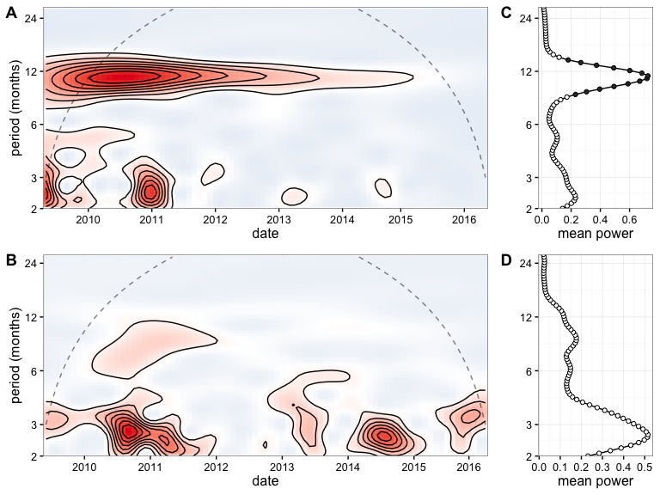

***Figure 2:*** *Wavelet decomposition of the number of new nests established by P. rubricauda(A) and P. lepturus (B) for the study period. The red colour indicates a higher power, and the dashed lines indicate the cone of influence, above which results should not be considered. C and D, depict the mean power across time with filled circles illustrating those periods at which the periodicity was significantly different from the random expectation at the 0.05 level.*

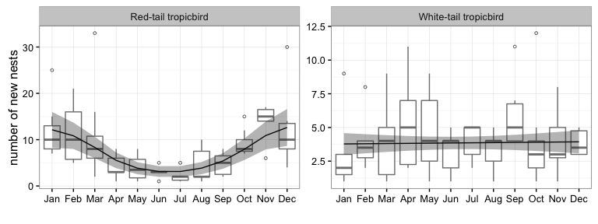

***Figure 3:*** *Number of new nests observed per month. All boxes cover the 25th–75th percentiles, the middle line marks the median, and the maximum length of the whiskers is 1.5 times the interquartile range. Points outside this range show up as outliers.*

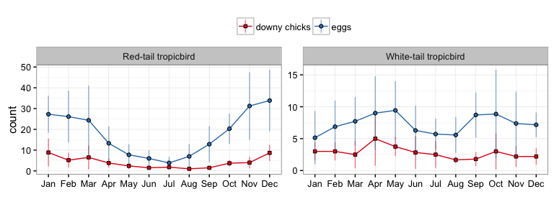

***Figure 4:*** *Mean number of observed downy chicks (red) and eggs(blue) per month. Vertical bars represent standard deviation.*

Consistent with Prys-Jones and Peet (1980) we found differing regimes for *P. rubricauda* and *P.lepturis*. While *P. rubricauda* breeds with a marked periodicity, *P.lepturis* does not. One difference, however, while Prys-Jones and Peet (1980) identified the lower peak of season to be August-September, our data supports a trough slightly earlier in June-July. The possible change in the breeding phenology of *P. rubricauda* might be related weather or resource conditions but a longer data set might be desirable to explore this relationship.

# References

Prys-Jones, R. P., and C. Peet. 1980. “Breeding periodicity, nesting success and nest site selection among red-tailed tropicbirds Phaethon rubricauda and white-tailed tropicbirds P. lepturus on Aldabra Atoll.” *Ibis* 122 (1): 76–81. doi:[10.1111/j.1474-919X.1980.tb00873.x](https://doi.org/10.1111/j.1474-919X.1980.tb00873.x).